**TECHNICAL REPORT ON RETAILNOVA INC. SALES PERFORMANCE ANALYSIS.**

**INTRODUCTION:**

This report presents a comprehensive sales and transaction analysis for RetailNova Inc., a dynamic mid-sized retail enterprise operating across multiple regions in the United States. Utilizing interactive data visualization tools in Power BI, the analysis aims to uncover patterns in customer behavior, regional sales performance, product category trends, and operational efficiency. Through the exploration of sales data from 2014 to 2017, the report identifies key revenue drivers, underperforming segments, and opportunities for strategic growth. By leveraging advanced analytics, RetailNova Inc. is equipped to make informed decisions that enhance sales productivity, optimize logistics, and elevate customer satisfaction.

**PROBLEM STATEMENT:**

RetailNova Inc., a mid-size retail company, needs to monitor, evaluate, and improve its sales performance and customer service across regions, categories, and time periods. The leadership team is particularly interested in understanding:

1. Where and when sales are strongest or weakest
2. Which customer segments or states drive revenue
3. What shipment modes are efficient
4. Why sales may decline in certain cases

2. **BUSINESS OBJECTIVES:**

1. Track and measure total sales and transactions over time.
2. Analyze performance by region, state, city, and segment.
3. Understand weekly sales behavior and optimize operations accordingly.
4. Identify the key drivers and inhibitors of sales.
5. Deliver actionable recommendations for growth and efficiency.

**DASHBOARD OVERVIEW:**

The Power BI dashboard designed for the analysis contains three different pages as follows:

**Page 1: Sales and Transactions Report by Period**

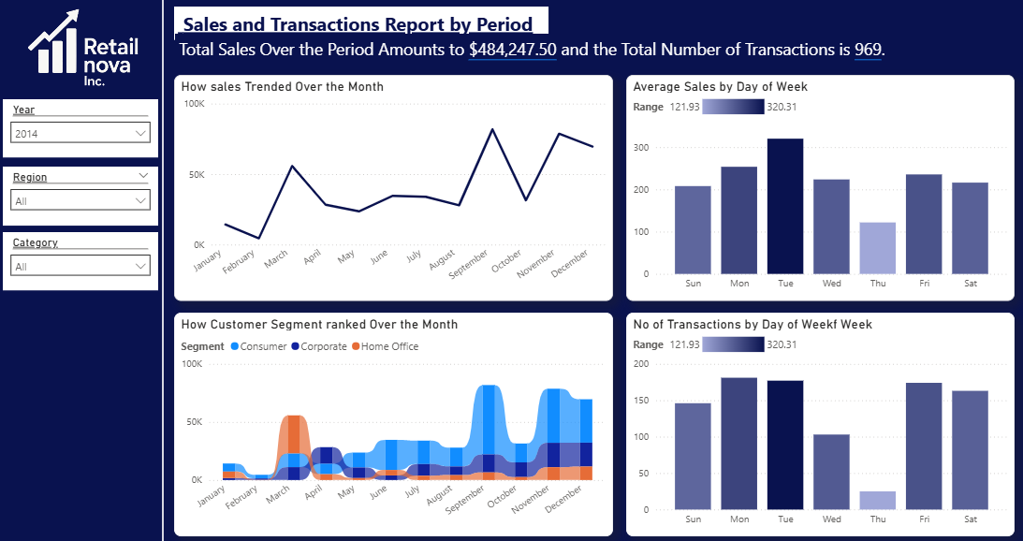

Purpose:

This page explores how sales and transactions behave across the calendar year, segmented by customer types and day-of-week patterns.

**Visuals & KPIs:**

* Total Sales: $484,247.50
* Total Transactions: 969
* Monthly Sales Trend: Shows how sales fluctuate from January to December
* Customer Segment Performance by Month: Breakdown across Consumer, Corporate, and Home Office
* Average Sales by Day of Week
* Number of Transactions by Day of Week
* Filters: Year, Region, Category

**OBSERVATIONS:**

* Sales peak mid-year and again near year-end.
* Consumer segment dominates, with Corporate and Home Office trailing.
* Mid-week (Tue–Thu) sees the highest sales and transaction activity.
* Sunday consistently has the lowest sales.

**Page 2: Sales and Transactions Report by Location**

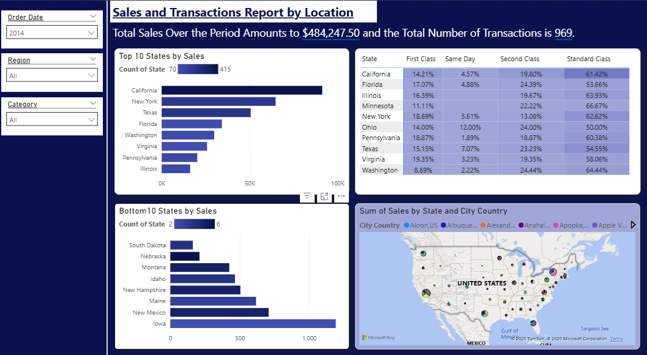

**Purpose:**

This page assesses geographic contributions to overall sales and identifies underperforming regions or states.

**Visuals:**

* Top 10 States by Sales
* Bottom 10 States by Sales
* Shipping Mode Distribution by State
* Sales by State and City (Map)
* Filters: Order Date, Region, Category

**OBSERVATIONS:**

* California, New York, and Texas lead in sales.
* States like South Dakota, Montana, and Idaho fall at the bottom.
* Standard Class dominates shipment mode (~60% in most states).
* Same-day delivery usage is minimal.
* Mapping visual shows strong clusters in urban locations.

**Page 3: Advanced Sales Exploration**

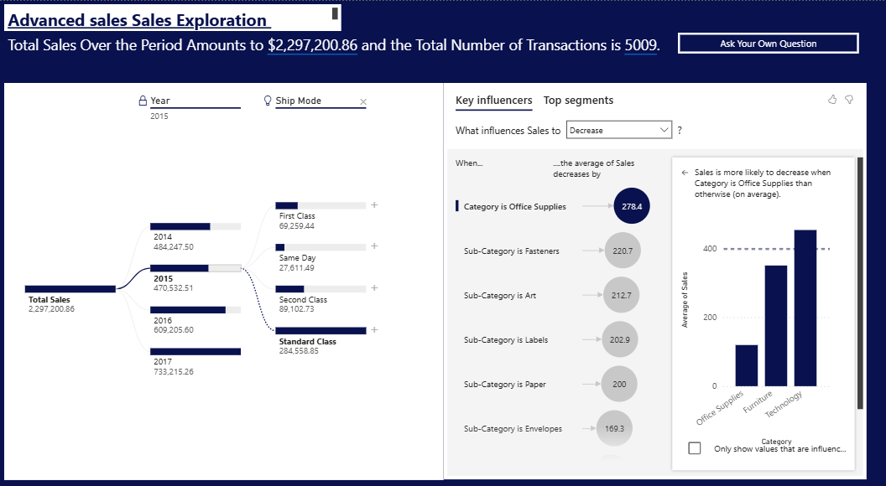

**Purpose:**

This page provides a high-level multi-year sales breakdown and explores influencing factors behind sales increases or decreases.

**Visuals:**

* Total Sales (2014–2017): $2,297,200.86
* Transaction Count: 5,009
* Annual Sales Growth
* 2014: $484K
* 2015: $470K
* 2016: $609K
* 2017: $733K
* Sales by Shipping Mode
* AI Key Influencers Analysis

**OBSERVATIONS:**

* Healthy year-over-year growth, especially from 2016 onward.
* Key sales inhibitors (according to AI analysis):
* Categories like Office Supplies
* Subcategories like Fasteners, Envelopes, Paper
* These product groups have consistently lower average sales.

**METHODOLOGY**

* Data Collection: Historical sales data (2014–2017), transactions, customer segments, geographic details.
* Visualization: Power BI is used to build interactive charts, KPI cards, and AI insights.
* Segmentation: By state, category, shipping mode, and customer type.
* AI Insights: Used Power BI’s Key Influencer visual to identify drivers of sales performance.
* Filters & Slicers: Implemented to allow users to drill into regions, years, and categories.

**KEY INSIGHTS**

1. **Sales Performance Over Time:** The company’s sales exhibited clear seasonal trends, with notable peaks occurring between March to May and again during the fourth quarter (September to December). This suggests a correlation between consumer demand and seasonal cycles, possibly influenced by promotional events or holidays.
2. **Customer Segment Analysis:** Among the three customer segments—Consumer, Corporate, and Home Office—the Consumer segment consistently generated the highest volume of sales throughout the year. This indicates that RetailNova Inc.’s core customer base is primarily composed of individual or household buyers, and further investments in consumer-targeted promotions could yield higher returns.
3. **Sales and Transactions by Day of Week:** Sales activity varied significantly across the days of the week, with Tuesdays through Thursdays showing the highest average sales and transaction volumes. Conversely, Sundays and Saturdays recorded the lowest sales figures, indicating that customer engagement is strongest during weekdays and tapers off during the weekend.
4. **Regional Sales Distribution:** The analysis revealed that California, New York, and Texas were the top-performing states in terms of total sales, making them the most lucrative markets for RetailNova Inc. In contrast, states like South Dakota, Idaho, and Montana appeared at the bottom of the sales ranking, suggesting either limited market presence, logistical constraints, or lower demand in these areas.
5. **Shipping Mode Usage by State:** Across all major states, Standard Class shipping was the most commonly used mode, accounting for over 60% of shipping activity in many regions. Second Class was the next most used, while Same Day and First Class modes were less prevalent. This may reflect customer price sensitivity or limitations in faster delivery logistics.
6. **Multi-Year Sales Growth:** Sales figures showed a steady upward trajectory from 2014 to 2017, with total revenue growing from $484,247.50 in 2014 to $733,215.26 in 2017, culminating in a total of $2,297,200.86 across the four years. This demonstrates strong year-over-year growth and signals the company’s expanding market presence.
7. **Transaction Volume Trends:** A total of 5,009 transactions were recorded across the entire period, aligning proportionally with the revenue increase each year. This supports the observation that both customer acquisition and retention strategies were improving over time.
8. **Product Category Performance (AI Insights):** AI-driven insights from Power BI indicated that sales tend to decline when the primary product category is Office Supplies, especially within sub-categories such as Fasteners, Envelopes, Paper, Labels, and Art Supplies. These items generated significantly lower average sales, suggesting they are either low-demand or low-margin products.
9. **City-Level Distribution and Mapping:** Geospatial analysis confirmed that urban centers such as Los Angeles, New York City, and Houston serve as major revenue hubs. These cities also align with states that lead in sales volume, reinforcing the importance of city-specific marketing and distribution strategies.

**RECOMMENDATION**

* **Enhance Marketing in High-Performing States:** RetailNova Inc. should intensify its marketing and promotional efforts in high-performing states such as California, New York, and Texas, as these regions contribute the largest share of total sales. Customized campaigns, localized offers, and loyalty programs in these markets can further drive revenue growth.
* **Address Sales Gaps in Underperforming States:** The company should conduct targeted investigations into low-performing states like South Dakota, Idaho, and Montana to determine the root causes of weak sales. Strategic initiatives such as regional promotions, localized advertising, or new distribution partnerships could help penetrate these markets more effectively.
* **Optimize Shipping Strategies for Customer Satisfaction and Efficiency:** Given the overwhelming reliance on Standard Class shipping, RetailNova should consider optimizing its logistics network to encourage broader adoption of faster shipping modes, such as Same Day and First Class, especially in metro areas where faster delivery can enhance customer satisfaction and brand loyalty.
* **Leverage Weekday Sales Trends for Promotional Timing:** Since sales and transactions peak on Tuesdays, Wednesdays, and Thursdays, the company should align major marketing campaigns, flash sales, and product launches with these days to capitalize on peak customer engagement and maximize conversion rates.
* **Reevaluate Low-Performing Product Categories:** RetailNova should review its portfolio of underperforming sub-categories, particularly within the Office Supplies category, including Fasteners, Envelopes, and Labels. These items may benefit from being bundled with higher-performing products, rebranded, discounted, or even discontinued if they consistently show weak performance.
* **Strengthen Consumer Segment Engagement:** As the Consumer segment is the dominant revenue driver, the company should continue to focus on this group through personalized offers, loyalty rewards, and online engagement campaigns. At the same time, targeted strategies should be developed to increase penetration in Corporate and Home Office segments to diversify revenue sources.
* **Expand Urban Market Presence:** Urban areas, especially major cities like Los Angeles, New York, and Houston, demonstrate strong sales potential. RetailNova should explore setting up local fulfillment hubs or expanding partnerships in these cities to reduce delivery times and improve service reliability.
* **[**
* **Capitalize on Year-Over-Year Sales Growth:** With strong annual growth trends from 2014 to 2017, the company should invest in scaling infrastructure, inventory management systems, and workforce capabilities to support continued expansion and prepare for increased demand in future periods.

**CONCLUSION**

The comprehensive analysis of RetailNova Inc.’s sales and transaction data, drawn from Power BI visualizations, provides clear insights into the company's performance across periods, customer segments, geographical regions, and product categories. The findings reveal that the business has experienced consistent growth over four years, with strong contributions from key states like California, New York, and Texas, and dominant customer engagement from the Consumer segment.

Sales patterns indicate that customer activity is highest mid-week and during certain months of the year, reflecting predictable behavioral trends that the company can strategically leverage. However, the analysis also uncovered opportunities for improvement in underperforming regions and product categories, particularly within the Office Supplies segment and in less active states.

By addressing these gaps through targeted marketing, supply chain enhancements, and customer segmentation strategies, RetailNova Inc. is well-positioned to further strengthen its market presence, improve operational efficiency, and boost revenue. The application of data-driven decision-making, supported by Power BI’s advanced analytical tools, will enable the company to remain agile, competitive, and customer-centric in an evolving retail landscape.